WEEK 3 DAY 1- Mon 19 Oct. 26
FASTAPI DEMO
In pycharm terminak : python -m pip install fastapi uvicorn
Uvicorn app:main –reload
Final main.py:
from fastapi import FastAPI, HTTPException
from pydantic import BaseModel
app = FastAPI()
@app.get("/")
def home():
return {"message": "hello from fastapi"}
@app.get("/hello/{name}")
def say_hello(name: str):
return {"message": f"Hello {name}"}
class Product(BaseModel):
id: int
name: str
price: float
products = []
@app.get("/products")
def get_products():
return products
@app.post("/products")
def add_product(product: Product):
products.append(product)
return product
@app.get("/products/{product_id}")
def get_product(product_id: int):
for product in products:
if product.id == product_id:
return product
raise HTTPException(
status_code=404,
detail="Product not found"
)
@app.put("/products/{product_id}")
def update_product(product_id: int, updated_product: Product):
for index, product in enumerate(products):
if product.id == product_id:
products[index] = updated_product
return updated_product
raise HTTPException(
status_code=404,
detail="Product not found"
)
@app.delete("/products/{product_id}")
def delete_product(product_id: int):
for index, product in enumerate(products):
if product.id == product_id:
deleted = products.pop(index)
return {
"message": "Product deleted",
"product": deleted
}
raise HTTPException(
status_code=404,
detail="Product not found"
)

In PyCharm terminal:
uvicorn main:app --reload
You should see:
INFO: Uvicorn running on http://127.0.0.1:8000
``
Uising Swagger Documentation
http://127.0.0.1:8000/docs
In Postman:
1: Add Product
Method : POST
URL: http://127.0.0.1:8000/products
Body: Select: Body raw JSON
{
"id": 1,
"name": "Laptop",
"price": 50000
}

2: Add Another Product then send
{
"id": 2,
"name": "Mobile",
"price": 25000
}

3: View All Products
Method: GET
URL: http://127.0.0.1:8000/products
Output:
[
{
"id": 1,
"name": "Laptop",
"price": 50000
},
{
"id": 2,
"name": "Mobile",
"price": 25000
}
]

4: Get Product By ID
Method: GET
URL: http://127.0.0.1:8000/products/1
Output:
{
"id": 1,
"name": "Laptop",
"price": 50000
}
5: Update Product
Method: PUT
URL: http://127.0.0.1:8000/products/1
`
Body:
{
"id": 1,
"name": "Gaming Laptop",
"price": 75000
}
Click Send
Output:
{
"id": 1,
"name": "Gaming Laptop",
"price": 75000
}

6: Verify Update
Method: GET
URL: http://127.0.0.1:8000/products
Output:
[
{
"id": 1,
"name": "Gaming Laptop",
"price": 75000
},
{
"id": 2,
"name": "Mobile",
"price": 25000
}
]

7: Delete Product
Method: DELETE
URL: http://127.0.0.1:8000/products/1
Output:
{
"message": "Product deleted",
"product": {
"id": 1,
"name": "Gaming Laptop",
"price": 75000
}
}
8: Verify Deletion
Method :GET
URL: http://127.0.0.1:8000/products
Output:
[
{
"id": 2,
"name": "Mobile",
"price": 25000
}
]
9: Try Accessing Deleted Product
Method: GET
URL: http://127.0.0.1:8000/products/1
Output:
{
"detail": "Product not found"
}
Status:
404 Not Found
The complete CRUD application:
- Create → POST
- Read All → GET /products
- Read One → GET /products/{id}
- Update → PUT
- Delete → DELETE
- End result for evidence:
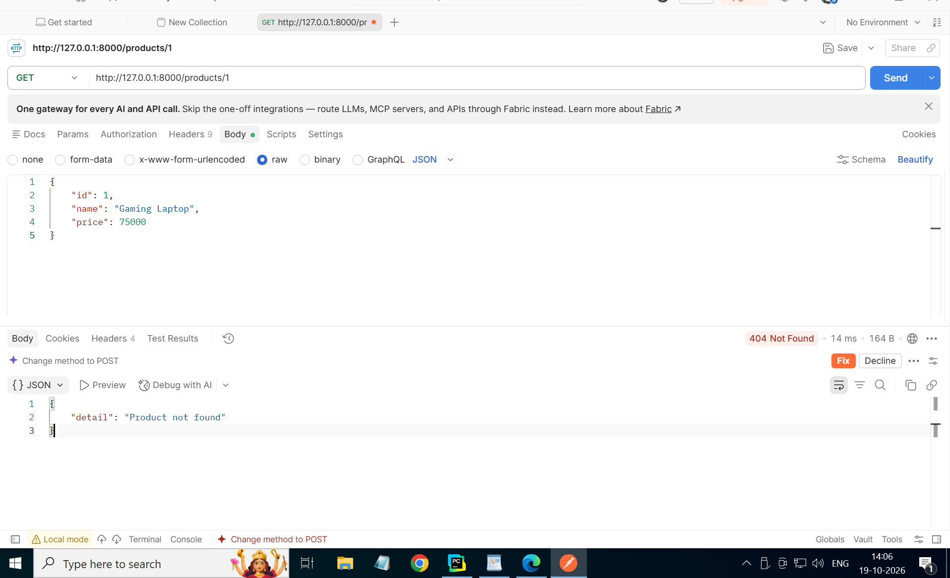
POSTBREAK demo-
POSTGRESQL: make table and db
Create database fastapi_demo;
CREATE TABLE products (
id INT PRIMARY KEY,
name VARCHAR(100),
price DECIMAL(10,2)
);

IN pycharm:
Terminal : python -m pip install psycopg2-binary
Python file postbreak_psycopgdemo.py (name it as main.py):
from fastapi import FastAPI
from pydantic import BaseModel
import psycopg2
app = FastAPI()
#connect fastapi to postgresql fastapi_demo
class Product(BaseModel):
id: int
name: str
price: float
def get_connection():
conn = psycopg2.connect(
host="localhost",
database="fastapi_store",
user="postgres",
password="Admin@123"
)
print("Connected to PostgreSQL successfully")
return conn
conn = get_connection()
conn.close()
result:
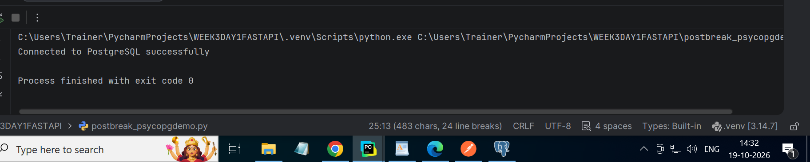
Code:
from fastapi import FastAPI
from pydantic import BaseModel
import psycopg2
app = FastAPI()
class Product(BaseModel):
id: int
name: str
price: float
def get_connection():
conn = psycopg2.connect(
host="localhost",
database="fastapi_store",
user="postgres",
password="Admin@123"
)
print("Connected to PostgreSQL successfully")
return conn
@app.get("/products")
def get_products():
conn = get_connection()
cursor = conn.cursor()
cursor.execute("SELECT * FROM products")
rows = cursor.fetchall()
cursor.close()
conn.close()
return rows
conn = get_connection()
conn.close()

screenshots :
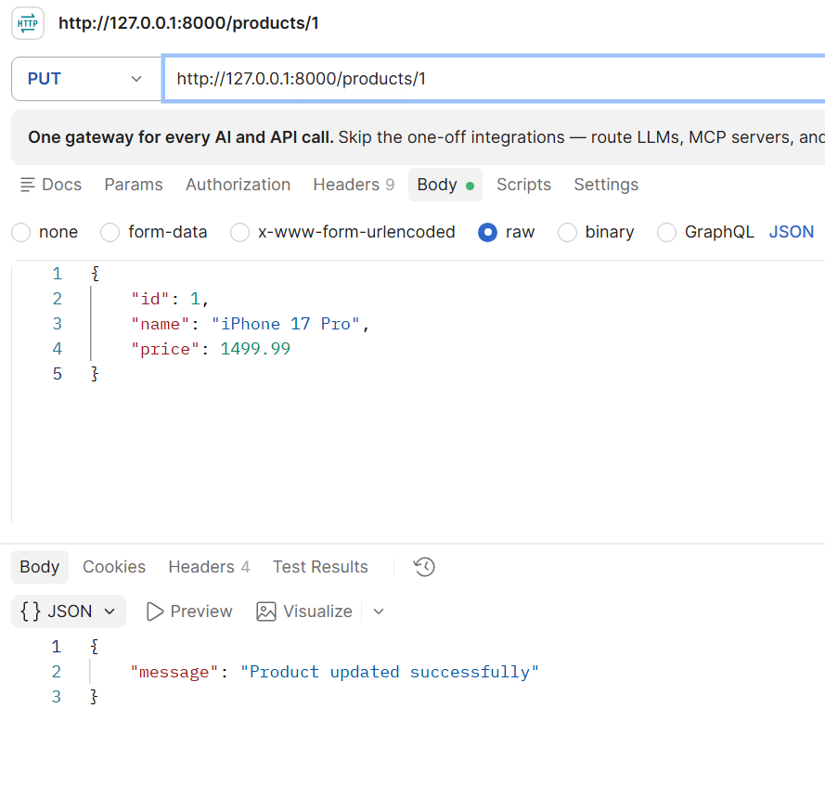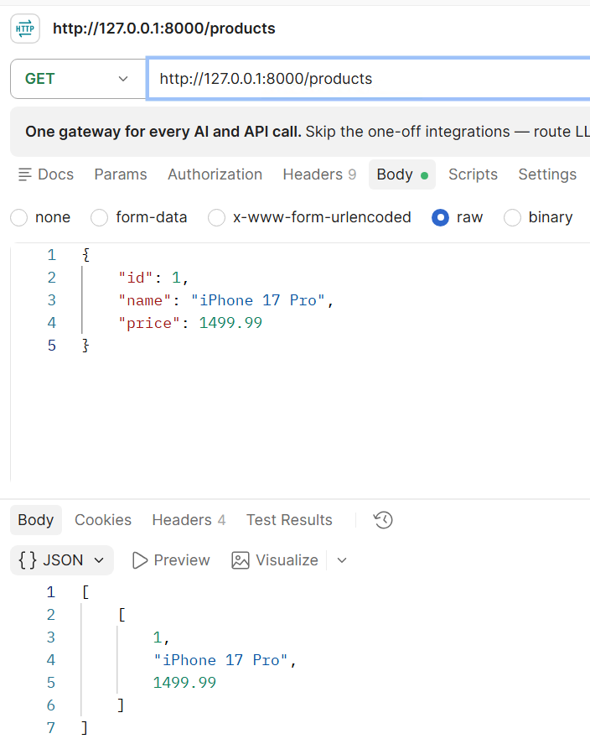
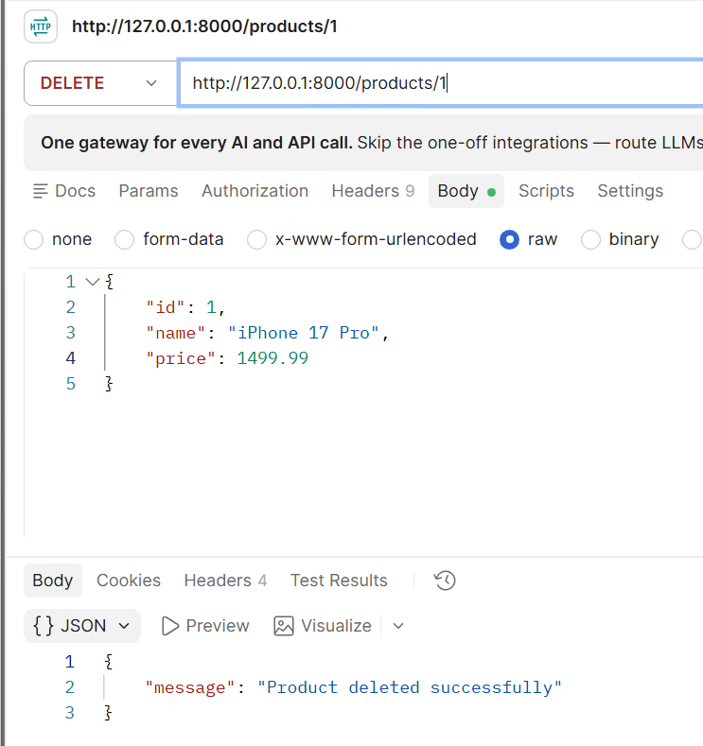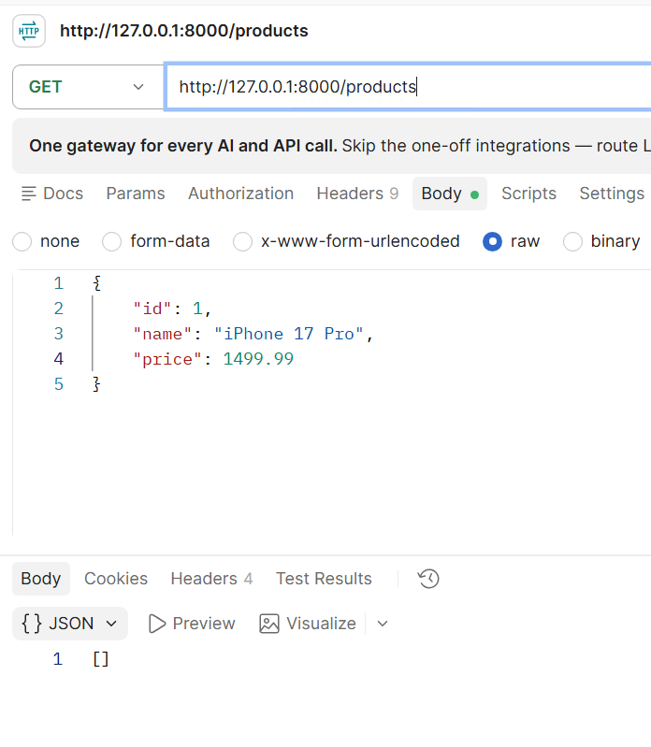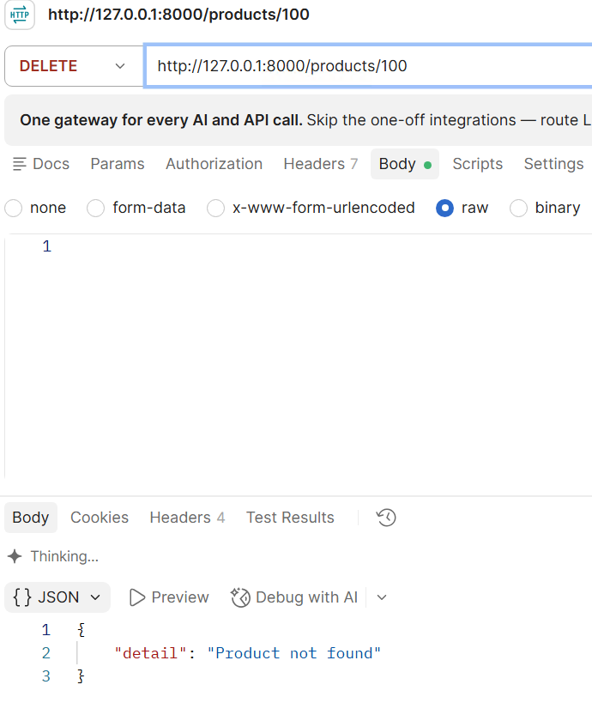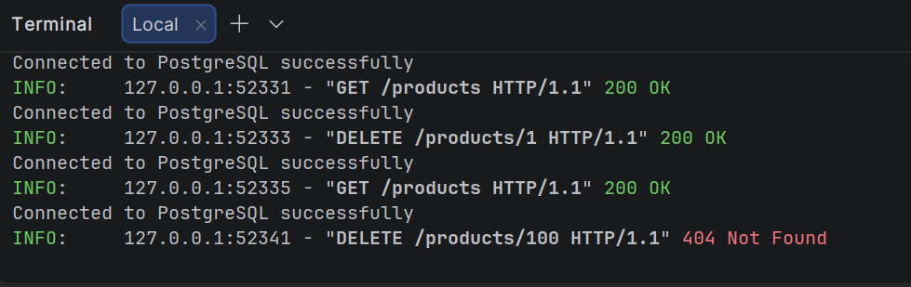
ASSIGNMENT: https://drive.google.com/file/d/1UZRJZJA9NaN806l-wXG8YdKLFea3LG6N/view?usp=sharing
In postgresql: create database library_store;
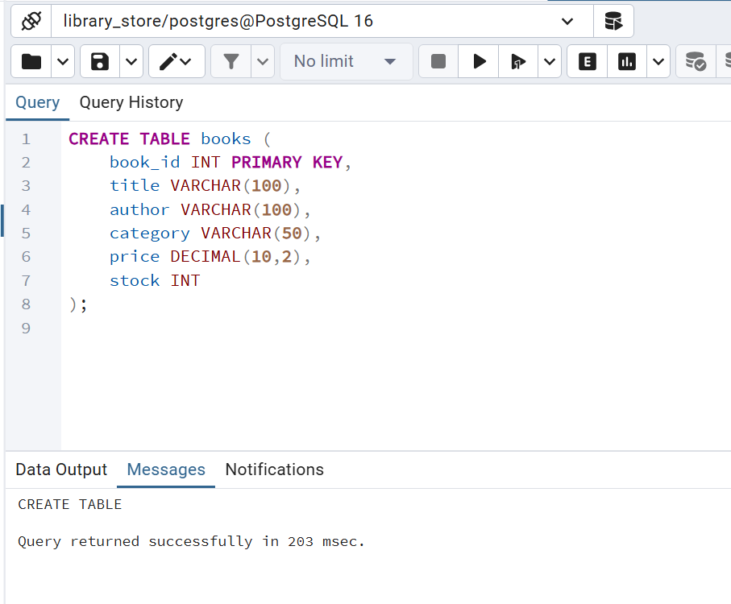
FILE: FASTAPI_ASSIGNMENT_CODE.py (when executing name it as main.py):
# Exercise — PostgreSQL CRUD from PyCharm
# Create a PostgreSQL database: CREATE DATABASE library_store;
# Connect to library_store and create this table:
# CREATE TABLE books (
# book_id INT PRIMARY KEY,
# title VARCHAR(100),
# author VARCHAR(100),
# category VARCHAR(50),
# price DECIMAL(10,2),
# stock INT
# );
#
# That is the only preparation to do in PostgreSQL.
# Everything else should be done from PyCharm.
# Create a project: # library_crud_project
# Install: python -m pip install psycopg2-binary
#
# Create: main.py
#
# Tasks
# 1. Connect Python to PostgreSQL using psycopg2 .
import psycopg2
def get_connection():
conn = psycopg2.connect(
host="localhost",
database="library_store",
user="postgres",
password="Admin@123"
)
# 2. Print: Connected to PostgreSQL successfully after the connection is established.
print("Connected to PostgreSQL successfully")
return conn
# Create connection
conn = get_connection()
cursor = conn.cursor()
# 3. Insert these 4 books from Python:
# 201 | Atomic Habits | James Clear | Self Help | 650 | 12
# 202 | Clean Code | Robert Martin | Technology | 900 | 8
# 203 | The Alchemist | Paulo Coelho | Fiction | 500 | 15
# 204 | Deep Work | Cal Newport | Productivity| 700 | 10
books = [
(201, "Atomic Habits", "James Clear", "Self Help", 650, 12),
(202, "Clean Code", "Robert Martin", "Technology", 900, 8),
(203, "The Alchemist", "Paulo Coelho", "Fiction", 500, 15),
(204, "Deep Work", "Cal Newport", "Productivity", 700, 10)
]
for book in books:
cursor.execute(
"""
INSERT INTO books
(book_id, title, author, category, price, stock)
VALUES (%s, %s, %s, %s, %s, %s)
""",
book
)
conn.commit()
print("Q3. Books inserted successfully")
# 4. Read and display all books.
print("\nQ4. All Books")
cursor.execute("SELECT * FROM books")
for row in cursor.fetchall():
print(row)
# 5. Display only books from the Technology category.
print("\nQ5. Technology Books")
cursor.execute("""
SELECT *
FROM books
WHERE category = 'Technology'
""")
for row in cursor.fetchall():
print(row)
# 6. Display books whose price is greater than 600 .
print("\nQ6. Books with Price > 600")
cursor.execute("""
SELECT *
FROM books
WHERE price > 600
""")
for row in cursor.fetchall():
print(row)
# 7. Update the price of book 202 to 950 .
cursor.execute("""
UPDATE books
SET price = 950
WHERE book_id = 202
""")
conn.commit()
print("\nQ7. Price updated successfully")
# 8. Update the stock of book 204 to 14 .
cursor.execute("""
UPDATE books
SET stock = 14
WHERE book_id = 204
""")
conn.commit()
print("Q8. Stock updated successfully")
# 9. Display the updated records.
print("\nQ9. Updated Records")
cursor.execute("""
SELECT *
FROM books
""")
for row in cursor.fetchall():
print(row)
# 10. Delete book 203 .
cursor.execute("""
DELETE FROM books
WHERE book_id = 203
""")
conn.commit()
print("\nQ10. Book 203 deleted successfully")
# 11. Display all remaining books.
print("\nQ11. Remaining Books")
cursor.execute("""
SELECT *
FROM books
""")
for row in cursor.fetchall():
print(row)
# 12. Add one new book of your own choice.
cursor.execute(
"""
INSERT INTO books
(book_id, title, author, category, price, stock)
VALUES (%s, %s, %s, %s, %s, %s)
""",
(
205,
"Rich Dad Poor Dad",
"Robert Kiyosaki",
"Finance",
800,
20
)
)
conn.commit()
print("\nQ12. New book added successfully")
# 13. Find the book with the highest price.
print("\nQ13. Highest Price Book")
cursor.execute("""
SELECT *
FROM books
ORDER BY price DESC
LIMIT 1
""")
print(cursor.fetchone())
# 14. Find the total stock available across all books.
print("\nQ14. Total Stock")
cursor.execute("""
SELECT SUM(stock)
FROM books
""")
total_stock = cursor.fetchone()
print("Total Stock =", total_stock[0])
# 15. Count how many books exist in each category.
print("\nQ15. Books Count By Category")
cursor.execute("""
SELECT category, COUNT(*)
FROM books
GROUP BY category
""")
for row in cursor.fetchall():
print(row)
cursor.close()
conn.close()
print("\nDatabase connection closed")

OUTPUT:
